**Gradient Boosting Regressor using Grid Search**

* + 5-fold cross validation
  + Optimal max depth of 4
  + Minimum sample size of 10
  + Learning rate of .05
  + Outcome: MSE of 0.0898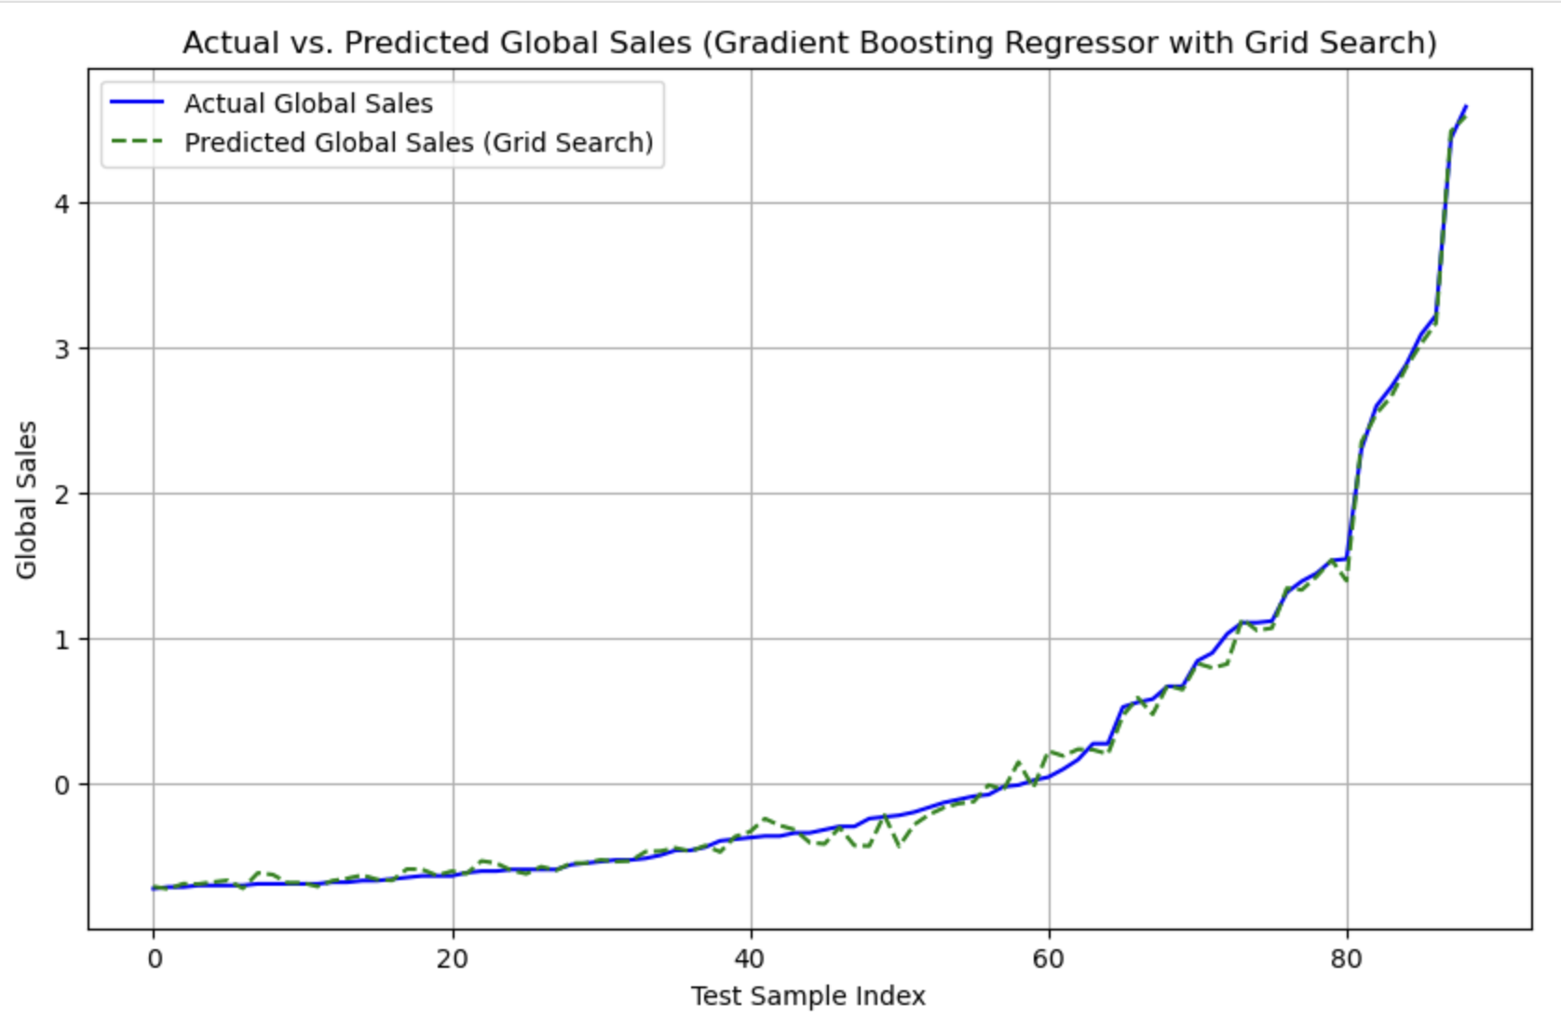

### **Conclusion:**

The Gradient Boosting Regressor model, combined with Grid Search, emerged as the most reliable model, striking a balance between avoiding overfitting and maintaining predictive accuracy. Although it didn't have the absolute lowest MSE, the Grid Search enhanced the model's robustness and versatility, making it more capable of handling unseen data compared to the other models.